Form 4 Chemistry Expt.: To Investigate Service Life of Dry Cells

Objective: To compare the service life of different dry cells using the Data-Logging system and hence determine which cell is the best buy

Introduction:
Advertisements claim that alkaline manganese cells have a long life compared to zinc-carbon cells. In this experiment, you are going to compare the service life of different brands of 1.5 V zinc-carbon cells with that of 1.5 V alkaline manganese cells. They are both AA size. Each cell is continuously discharged, until its voltage drops to 0 V. During the time, voltage readings are recorded at regular time intervals by the data-logging system.

Procedure:
1. Stick 2 dry cells (size AA) together in series using the adhesive tape provided. The positive terminal of one dry cell should be connected to the negative terminal of the other. Short-circuiting (i.e. allowing 2 positive terminals to touch) may cause over-heating, rupture of cell cases, damage of equipment or fire.
2. Connect the red and black wires to the positive and negative terminal of the dry cells respectively (as shown in the diagram below) using the adhesive tape.
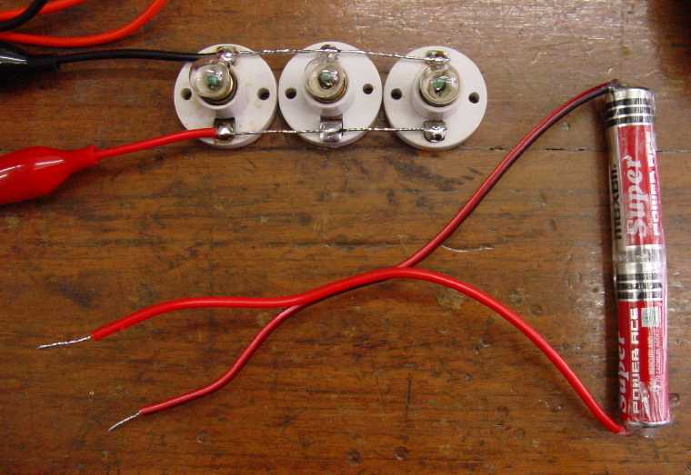

red wire
black wire
AA
AA
+
−
+
−

3. Connect the other end of the red and black wires to the light bulbs for a few seconds to check if the bulbs function properly. Disconnect the bulbs after checking.
4. From the Start Menu of the computer notebook, load the data-logging software by choosing the program ‘Science Workshop’.
5. Click and drag the ‘Analog Plug’ icon to Channel ‘A’ of the Interface and select the ‘Voltage sensor’.
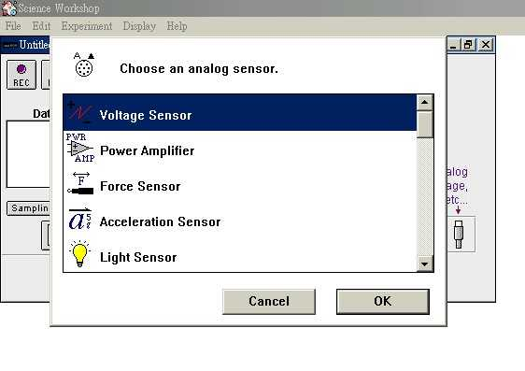
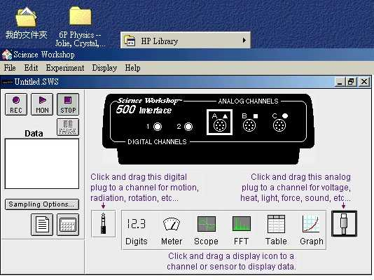

6. Click and drag also the ‘Graph’ and ‘Table’ display icons to Channel ‘A’.
7. Click the ‘Sampling Options’ button to select the recording rate. Choose ‘Slow’ and select the value ’60 s’. Data can then be recorded every minute.
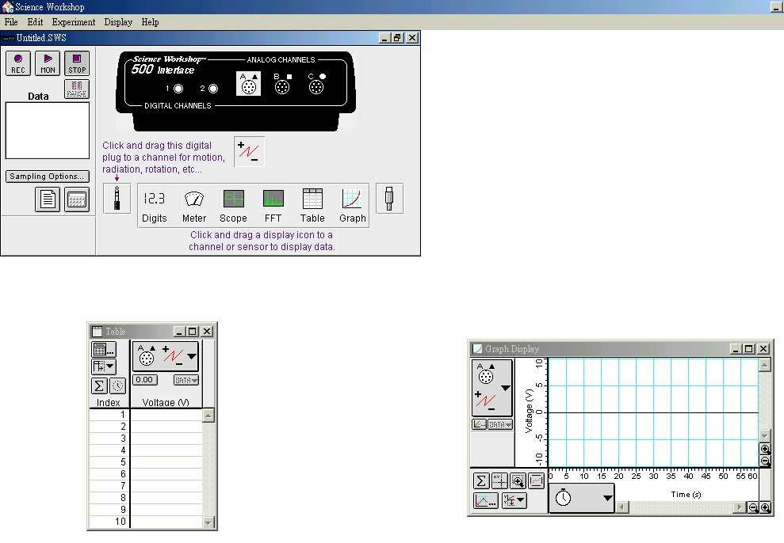
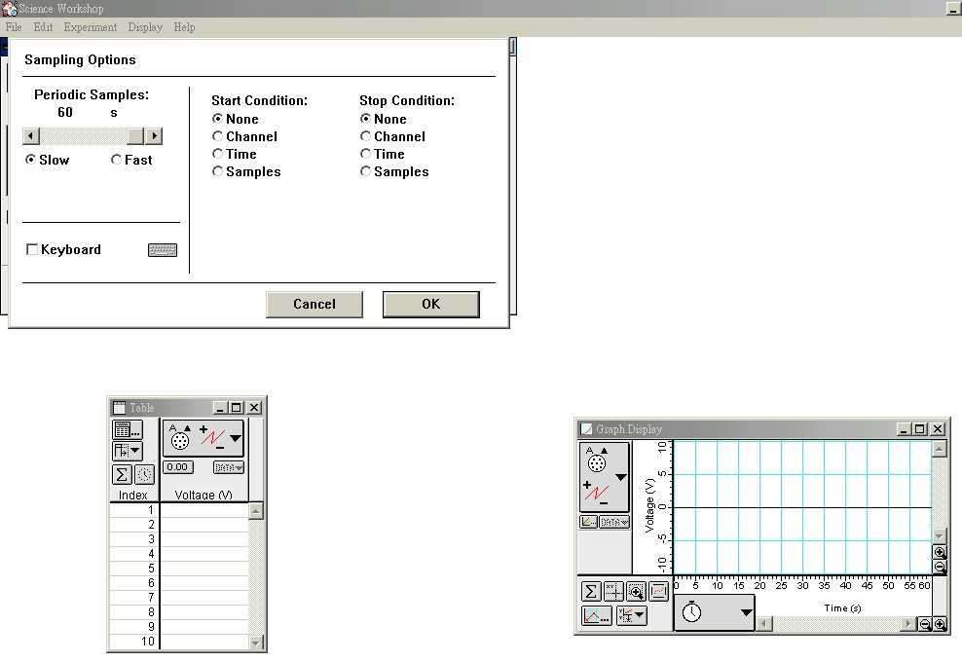

8. Connect the circuit (with light bulbs, dry cells and the data-logging interface in parallel) as shown below and press the ‘Record’ button simultaneously. Data will be recorded and displayed in the table. (Once the data-logging system starts recording, don’t touch the circuit to avoid missing any data.)
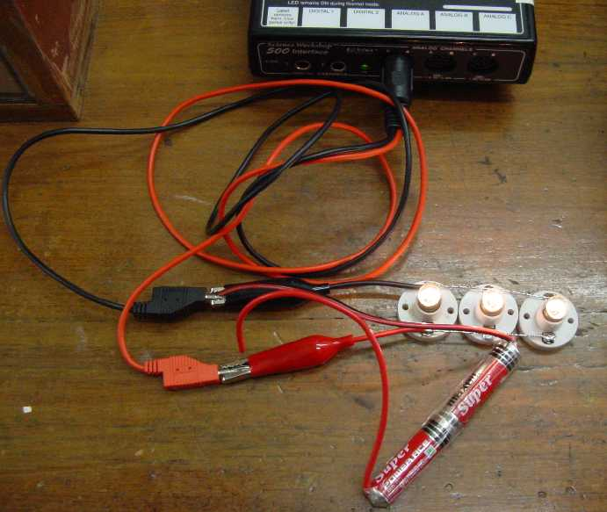
interface

9. After about 2 to 3 hours / when the voltage drops to zero, press the ‘Stop’ button and disconnect the circuit.
10. Select ‘Save As’ to save the data in a floppy disk in drive A using file names like ‘chem.sws’.
11. Repeat the above steps, using other type/brand of dry cells.

Printing Procedure
1. Load the Program ‘Science Workshop’ in the desktop computer which is connected to a printer.
2. Choose ‘Continue without the interface’ and then ‘OK’.
3. Open the file in the floppy disk A:\chem.sws
4. Activate the ‘Graph’ display and maximize it. Check whether the scales are appropriate. If not, click the x- and y-axes and adjust accordingly.
Voltage: min - 0 V Time: min. - 0 min
max. - ~3V max. - ~120 - 200 min
5. From the pull down menu, choose ‘Page Setup’ and then select ‘Landscape’.
6. To start printing, choose ‘Print Active Display’ and then select print ‘ALL’.
7. After printing, ‘Close’ the file and ‘Close’ the program ‘Science Workshop’ before you remove the floppy disk.

Discussion:
Compare the shape of the discharge curve (a plot of voltage against time) and read from the graph the service life of different dry cells. Determine which type of cell (zinc-carbon cell or alkaline manganese cell) and which brand is the best buy by comparing the service life and price of the cells.
Result of Discharge Curves of Zinc-Carbon Cell and Alkaline Manganese Cell
Energizer
(Gp.4)
Eveready _sample 2
(Gp.3)
Eveready _sample 1
(Gp.1)
First Choice
(Gp.2)
Duracell
(Gp.5)
Energizer (Titanium added)
(Gp.6)

